Lab 10

- Below, the Binary Search and Recursive Fibonacci algorithms are shown. In each case, what are the subproblems? Why do we say that the subproblems of Binary Search do not overlap and the subproblems of Recursive Fibonacci overlap? Explain.
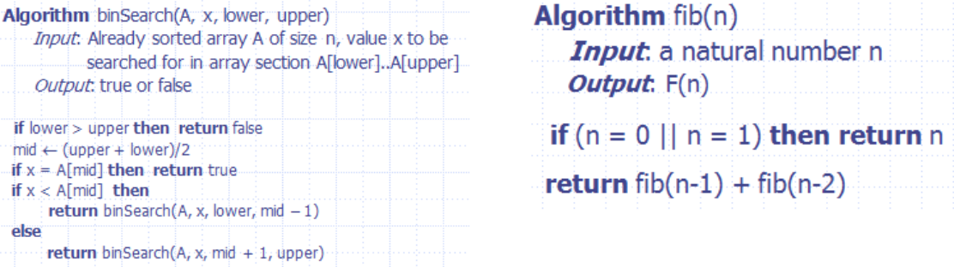

SOLUTION:
Sub problem is to divide the problem in such a way that its size is < Size of the original problem. In Binary search we divide the array to Left array which is less than n and divide the array to right which is also less than n based on the mid number. So, In case of binary search the
Sub problems are non-overlapping i-e doesn’t compute the same input redundantly. However In case of Recursive Fibonacci there is overlapping in different recursive calls like Fibonacci(5) means than Fibonacci(4) and Fibonacci(3) in a tree but in next iteration again from Fibonacci(4) there is Fibonacci(3) and Fibonacci(2) which in this case is computed again and we say that the subproblems in this case are overlapping.

- Consider the following instance of the Edit Distance problem: EditDistance(“maple”, “kale”). Taking the iterative dynamic programming approach to solve this problem, fill out the values in the table.

D | “” | “k” | “ka” | “kal” | “kale”

“” 0 1 2 3 4

“m” 1 1 2 3 4

“ma” 2 2 1 2 3

“map” 3 3 2 2 3

“mapl” 4 4 3 2 3

“maple” 5 5 4 3 2

- (Interview Question) Devise a dynamic programming solution for the following problem: Given two strings, find the length of longest subsequence that they share in common.

Different between substring and subsequence:

Substring: the characters in a substring of S must occur contiguously in S.

Subsequence: the characters can be interspersed with gaps.

For example: Given two Strings - “regular” and “ruler”, your algorithm should output 4.

Solution:

Algorithm LongestSubSequence(S1,S2)

Input: String S1 and S2 with length l1 and l2

Output: Output array that contains the length of S1[1..i] and Y[1..j]

L1=S1.length()

L2=S2.length()

for (i=0 to l1) do
L[i,0]←0
for(j=0 to l2) do
L[0.j]←0
for (i=1 to l1) do
for(j=1 to l2) do

if(S1[i]=S2[j])

L[i,j]←L[i-1,j-1]+1
Else
L[i,j]←max{L[i-1,j],L[i,j-1]}
Return L

4. (Optional Int erview Question) Devise a dynamic programming solution for the following problem:

Given a positive integer n, find the least number of perfect square numbers which sum to n. (Perfect square numbers are 1, 4, 9, 16, 25, 36, 49, …) For example, given n = 12, return 3; (12 = 4 + 4 + 4)

Given n = 13, return 2; (13 = 4 + 9)

Given n = 67 return 3; (67 = 49 + 9 + 9)

